­

TRIO Training Program

**Annual Evaluation Report**

**August 2018**

*By Kavita Mittapalli, Ph.D and David Keyes, Ph.D*

*MN Associates, Inc.*

**Table of Contents**

Introduction 4

Evaluation 5

Participants 6

Training Sessions 9

Course Ratings 10

Training Satisfaction 15

Knowledge Growth 20

Other Feedback 21

Conclusion and Recommendations 22

Works Cited 23

**List of Tables**

Table 1: Number of Participants and Survey Response Rates by Training Session 6

Table 2: List of Courses 9

Table 3: Completion Rates by Training Session 9

**List of Figures**

Figure 1: Map of Institutions Represented at TRIO Trainings 6

Figure 2: Participants by Whether They Attended a Previous Training Session 7

Figure 3: Number of Other Staff in Participants’ Departments 7

Figure 4: Were TRIO Participants Decision Makers in Their Departments? 8

Figure 5: 2018 Course Ratings 10

Figure 6: 2018 Course Ratings by Training Session 11

Figure 7: Online Course Ratings 12

Figure 8: Hybrid Course Ratings 13

Figure 9: In Person Course Ratings 14

Figure 10: Overall Satisfaction with Aspects of TRIO Trainings 15

Figure 11: Overall Satisfaction with Aspects of TRIO Trainings by Training Type 16

Figure 12: Online Course Satisfaction 17

Figure 13: Hybrid Course Satisfaction 18

Figure 14: In Person Course Satisfaction 19

Figure 15: Knowledge Growth (Pre Post) 20

Figure 16: Would Participants Want a Follow-Up Session? 21

Figure 17: Would Participants Recommend the Training to a Colleague? 21

# Introduction

Cuyahoga Community College (Tri-C), located in Cleveland, Ohio, has a long history of working with the federal TRIO programs. These programs are “federal outreach and student services programs designed to identify and provide services for individuals from disadvantaged backgrounds.”[1] Having been involved with TRIO since 1968, TriC is well versed in the intricacies of managing budgets and upholding statutory and regulatory requirements for the TRIO programs. As Tri-C itself puts it:

*Cuyahoga Community College takes pride in its almost 50-year history of stewardship of federally-funded TRIO grants. It has gained knowledge through accessing a wealth of internal expertise, thoughtful staffing decisions, taking advantage of professional development opportunities, and learning from our participants, colleagues and student-serving networks.*[2]

In fall 2016, Tri-C was awarded a grant by the United States Department of Education (USDE) to set up a TRIO Budget, Legislation and Regulations Training Program Office. This new office would then offer trainings to TRIO program administrators at institutions of higher learning throughout the United States. The ultimate goal of the grant is to increase the capacity of administrators throughout the country to effectively manage the budgets of their TRIO programs.

During 2017, three rounds of training sessions were offered, each of which had a different format (in person training, online training, and hybrid- a mix of in person and online trainings). In 2018, there were five training sessions, three in person, one online, and one hybrid

This report is an assessment of the performance in and satisfaction with these trainings. In addition to looking at overall satisfaction, the report breaks down the data to compare across types of session (in person, online, and hybrid) and across the last two years. It is hoped that lessons learned from this report will allow the Cleveland-based community college to improve its trainings in subsequent years.

# Evaluation

Throughout the two-year grant term, MN Associates (MNA), a woman-owned research and evaluation firm based in the Washington, DC area has served as the third-party evaluator. Over the course of the two years, MNA has worked closely with Cuyahoga Community College staff to evaluate the efficacy of the TRIO trainings, allowing Tri-C to make changes along the way to improve them.

MNA completed the evaluation of the program using a theory-based approach to study program design. This orientation applied a systematic process for defining what an educational innovation or intervention (e.g., TRIO trainings) is expected to do, in order to achieve desired teaching and learning outcomes and the process by which those impacts are realized (Chen, 1990, 2005; McLaughlin & Jordan, 1999). Program design and implementation was based on assumptions—explicit or otherwise—held by program designers and stakeholders about how specific actions were expected to mitigate an identified problem. Chen (2005) defines program theory as being simultaneously descriptive and prescriptive, with a resulting focus on identifying action-oriented explanations of program assumptions, inputs/processes, and activities.

In addition to this report, a report was completed in October 2017 that found the following:

* Overall, participants enjoyed and demonstrated knowledge growth as a result of the TRIO trainings.
* In person trainings showed the highest level of knowledge growth among participants compared to hybrid and online trainings.
* In person trainings were more popular than online or hybrid options.
* Those who took online trainings wanted more interactivity in them.

This report focuses primarily on the 2018 TRIO training sessions, with comparisons between 2018 and 2017 as well as comparisons between types of sessions (in person, online, and hybrid).

Data for this report come from surveys given prior to trainings as well as follow-up surveys given after them. This data combines quantitative ratings as well as open-ended qualitative feedback. Together, these two types of data provide both depth and breadth of participants’ experience with TRIO trainings.

# Participants

In 2018, 183 participants took part in TRIO trainings. The breakdown by training session as well as survey response rates are in Table 1 below.

Table 1: Number of Participants and Survey Response Rates by Training Session

| **Session** | **Number of Participants** | **Pre-Surveys Completed** | **Post Surveys Completed** |
| --- | --- | --- | --- |
| 2018 Online | 62 | 45 | 41 |
| 2018 Hybrid | 21 | 18 | 10 |
| 2018 In Person (June) | 32 | 40 | 24 |
| 2018 In Person (July) | 23 | 7 | 17 |
| 2018 In Person (August) | 45 | 36 | 31 |

Participants came from across the United States. The maps below show the locations of the institutions with which participants are associated (note that the few participants from Hawaii and Alaska are not shown in order to keep the maps small in size).

Figure 1: Map of Institutions Represented at TRIO Trainings

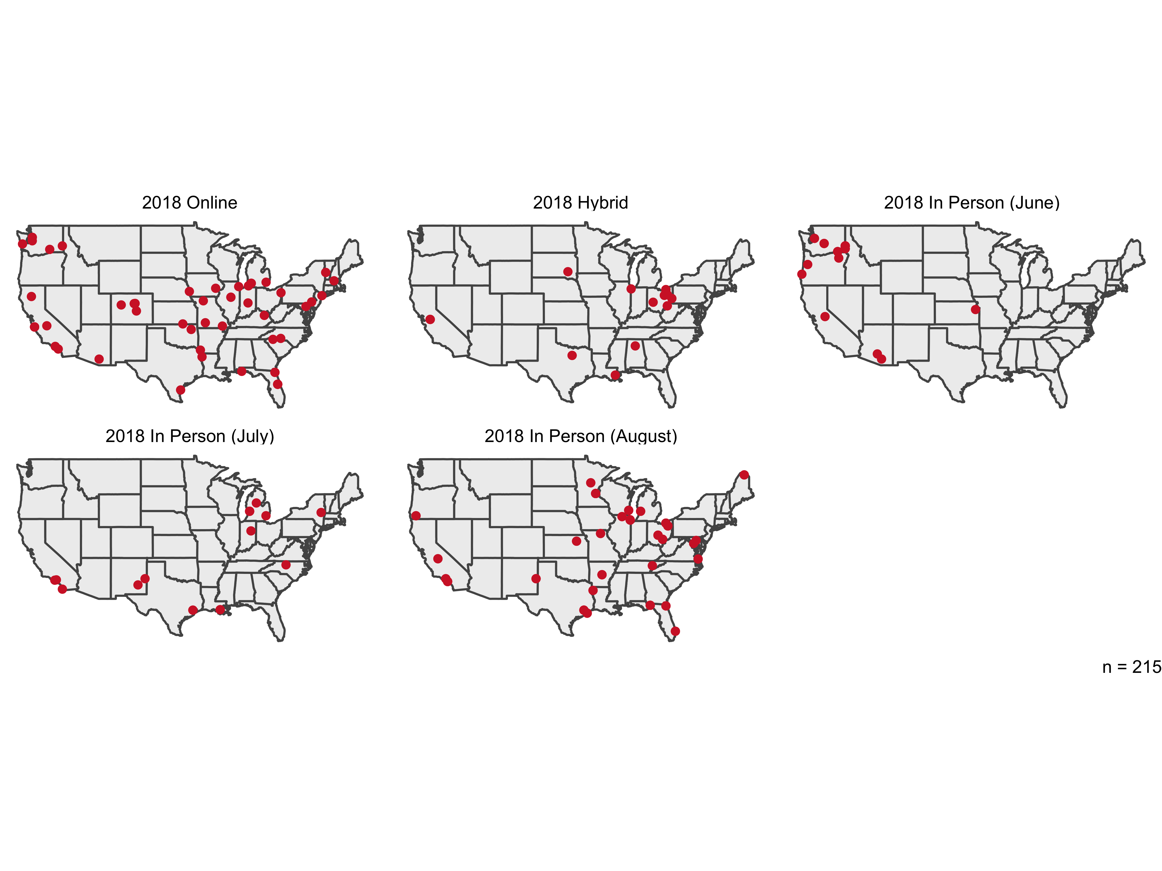

For most participants, the training they attended was their first such training. The highest percentage of those saying they had attended a previous session in 2018 was in the June in person session, when 45 percent were returning for a follow-up session. This higher than all of 2017 trainings except the in-person session, when the same percentage of participants were returning for a follow-up session.

Figure 2: Participants by Whether They Attended a Previous Training Session

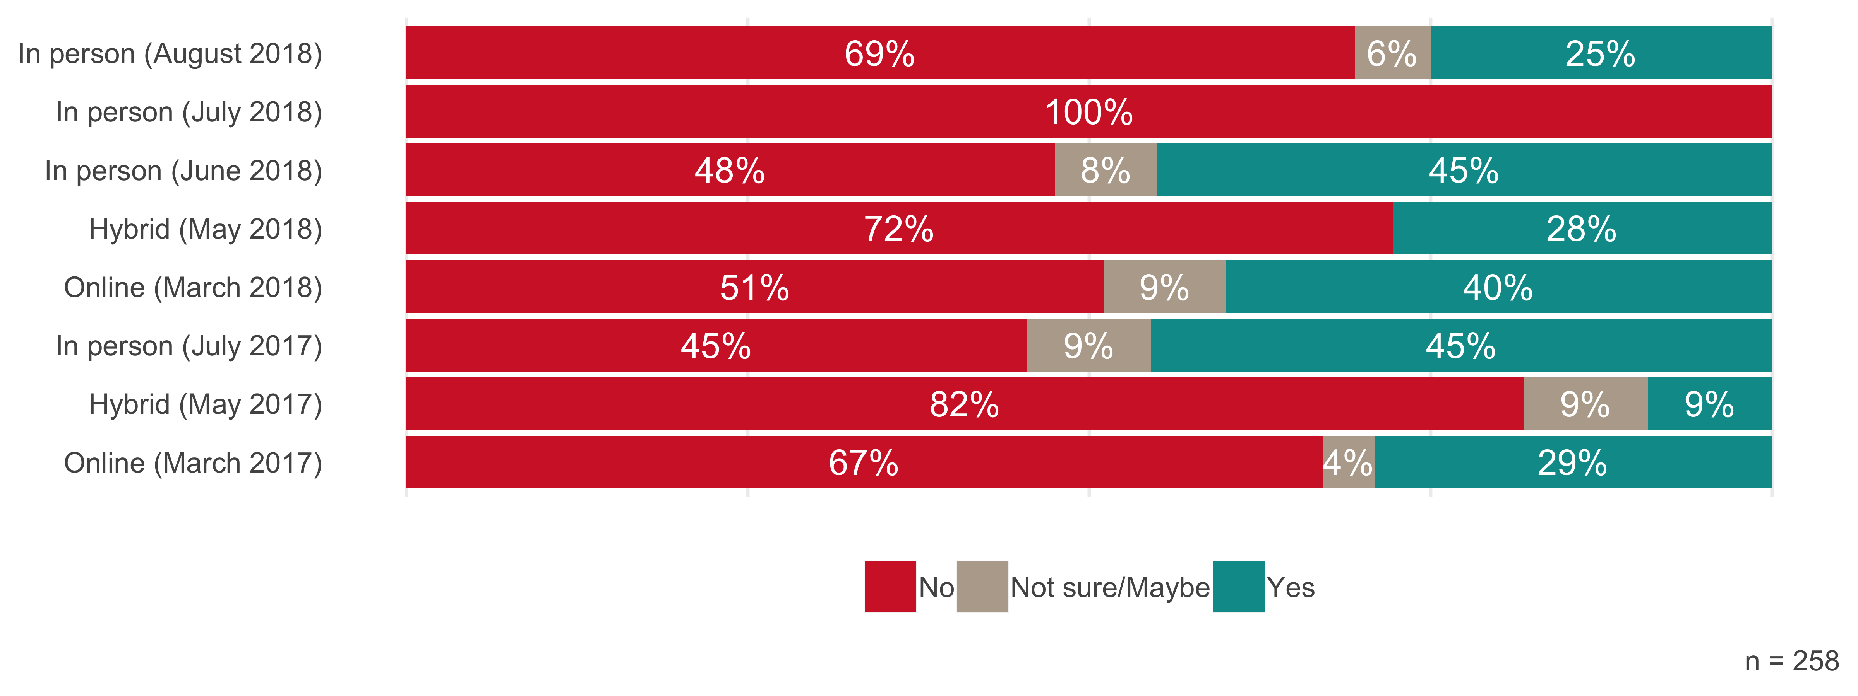

Participants were asked about the size of the departments they work in. As seen in the figure below, the vast majority of departments had 10 or fewer other staff members (in addition to the participant).

Figure 3: Number of Other Staff in Participants’ Departments

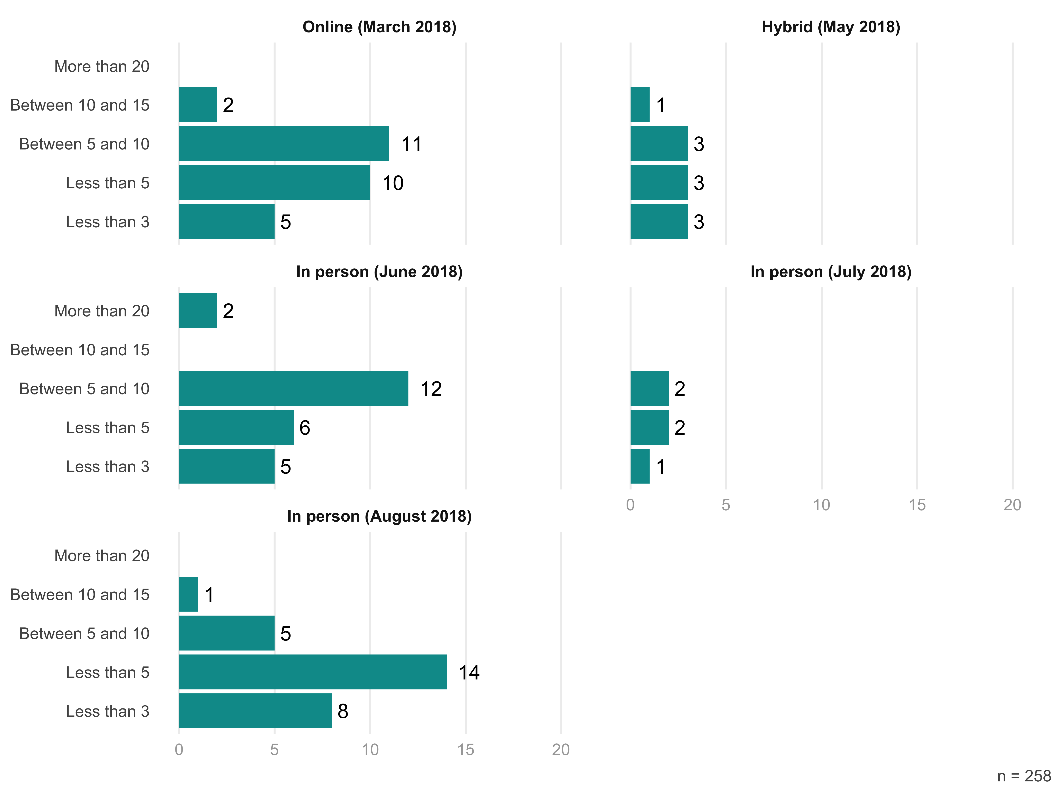

Participants also responded to a question asking whether they were the primary decision maker in their department. Of those who participated in 2018, 39 percent said they were. The full breakdown by training session is below.

Figure 4: Were TRIO Participants Decision Makers in Their Departments?

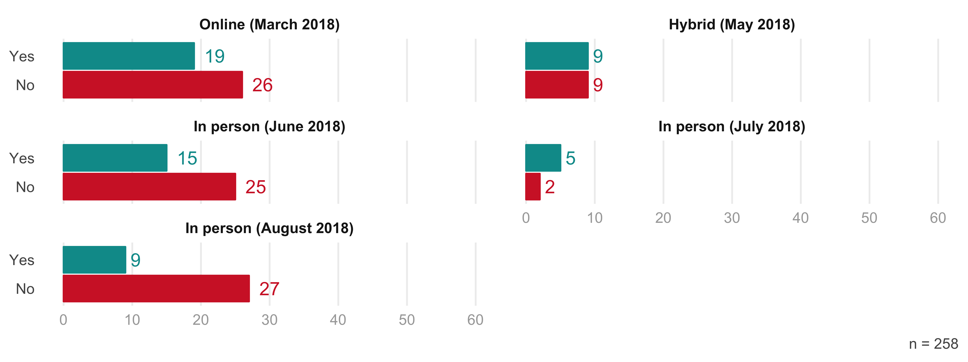

In a survey administered prior to the trainings, participants listed the challenges they face. They were clustered in three main areas. The first was staffing. Some said that staff turnover led to a lack of institutional knowledge about best practices for managing TRIO programs. One wrote, “It is a challenge if only 2 or 3 people are aware of the best ways to manage the TRIO budget and it seems that all staff should understand the allowable expenses, and how to effectively manage the budget to remain in compliance with the TRIO federal regulations.” Another staffing issue that participants face is having excess funds due to staff vacancies. As one put it, “The past year we had only 1 staff member for 7 months, so we have a lot of excess staffing monies to re-allocate/spend wisely.”

One of the main challenges participants identified is related to understanding federal regulations. A comment from one participant highlights this challenge. She wrote of feeling “confusion regarding [the Department of Education’s] position on (1) the cost of what is generally considered unallowable food and entertainment costs; and (2) prior-approval requirements for TRIO Student Support Services awards for meals & lodging costs for participants and staff on approved educational and cultural activities as codified in EDGAR 34 646.30 (e).”

A final area of concern expressed by participants was the current political climate. One participant said he fears that the “desire to reduce federal government expenses” will have an “impact on higher education,” including TRIO programs.

# Training Sessions

The TRIO training sessions this year included all of the courses from 2017 as well as one additional course: TRIO Management and Effective IT Controls.

Table 2: List of Courses

|  |  |
| --- | --- |
| COSO integrated internal control framework | TRIO Budget II |
| Educational Opportunity Center | Uniform Guidance |
| Educational Talent Search | Upward Bound and Upward Bound Math and Science |
| Student Support Services & McNair | Veterans Upward Bound |
| TRIO Budget I | TRIO Management and Effective IT Controls (new in 2018) |
|  |

The table below shows the percentage of participants in each session who completed the training. The numbers are all 90 percent and above.

Table 3: Completion Rates by Training Session

| **Training** | **Number of Participants** | **Number who Completed Course** | **Completion Rate** |
| --- | --- | --- | --- |
| Online (March) | 62 | 59 | 95% |
| Hybrid (May) | 21 | 21 | 100% |
| In Person (June) | 32 | 32 | 100% |
| In Person (July) | 23 | 21 | 91% |
| In Person (August) | 45 | 42 | 93% |

# Course Ratings

In their ratings of courses across sessions in 2018, there was little variation in the scores given by participants. The highest rated course (Trio Budget I) received an average rating of 3.3 (out of 4) while the lowest rated course (Coso Integrated Internal Control Framework) received a 2.9.

Figure 5: 2018 Course Ratings

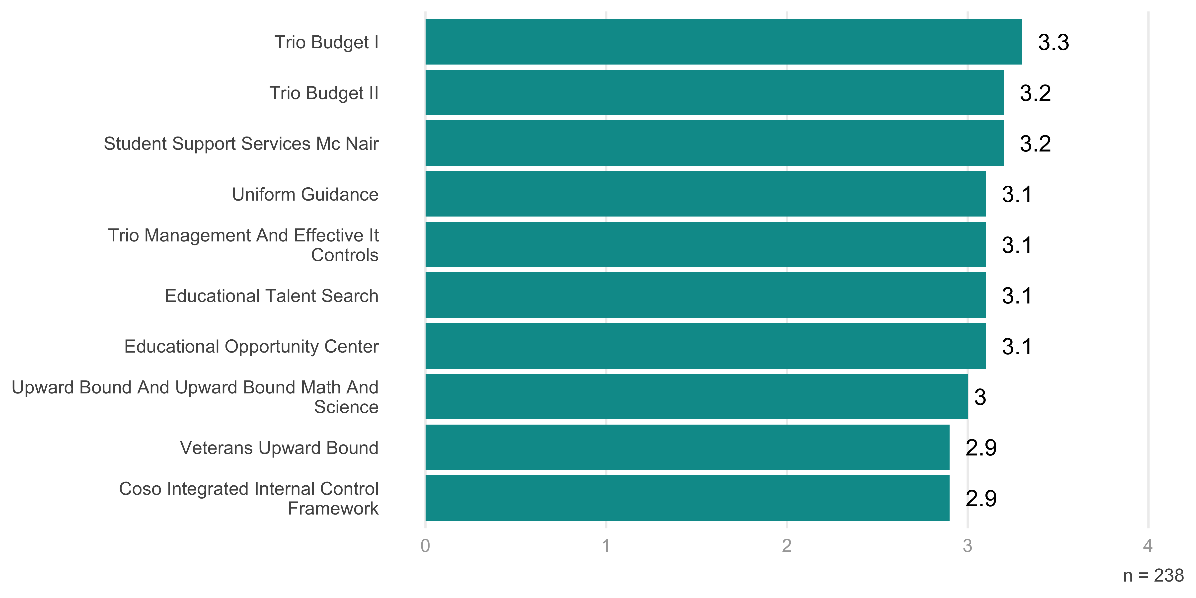

Looking at ratings across sessions, there is a bit more variation. The average rating for all courses was highest for in person trainings (3.2), followed by online sessions (3.0) and hybrid sessions (2.8). The figure below breaks this down by course, comparing ratings across types of training.

Figure 6: 2018 Course Ratings by Training Session

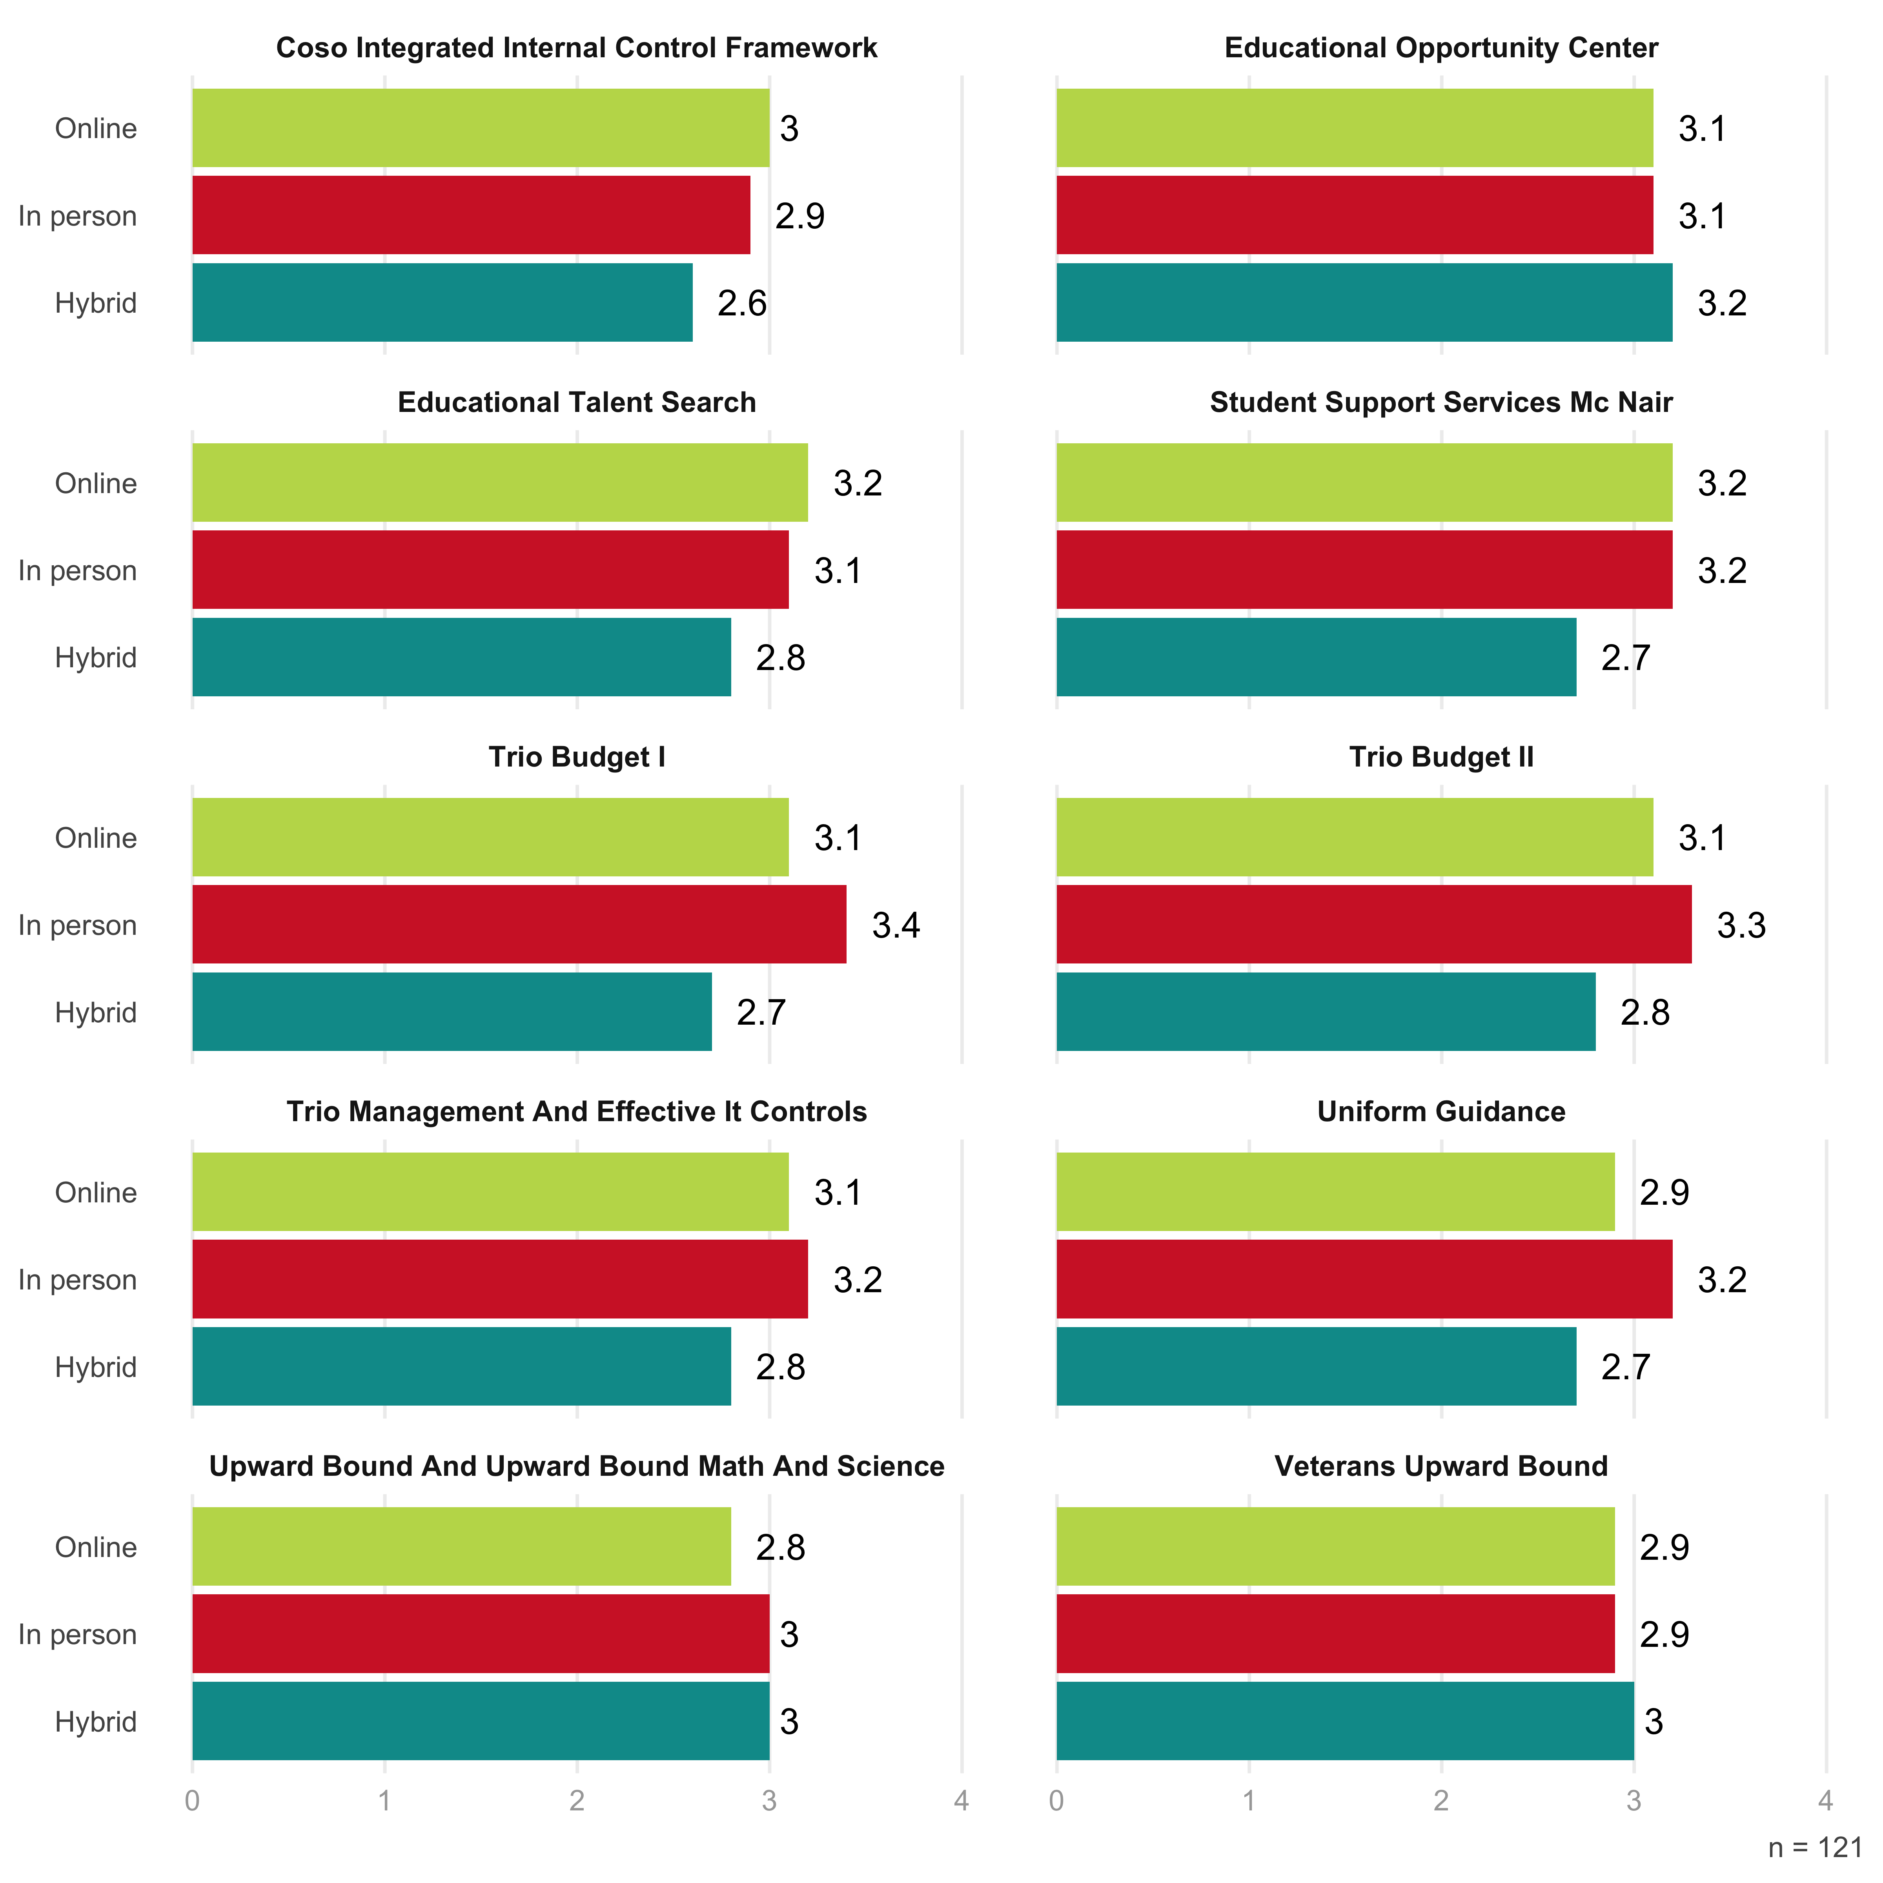

We can also compare ratings between the same types of sessions over the two years they have taken place. The set of figures below show the ratings given in 2017 and 2018 for online, hybrid, and in person courses.

For the online courses, the ratings between the two years are largely similar. The one course that had a noticeably higher rating in 2017 than 2018 was Uniform Guidance. 2018 saw higher ratings for the Veterans Upward Bound course.

Figure 7: Online Course Ratings

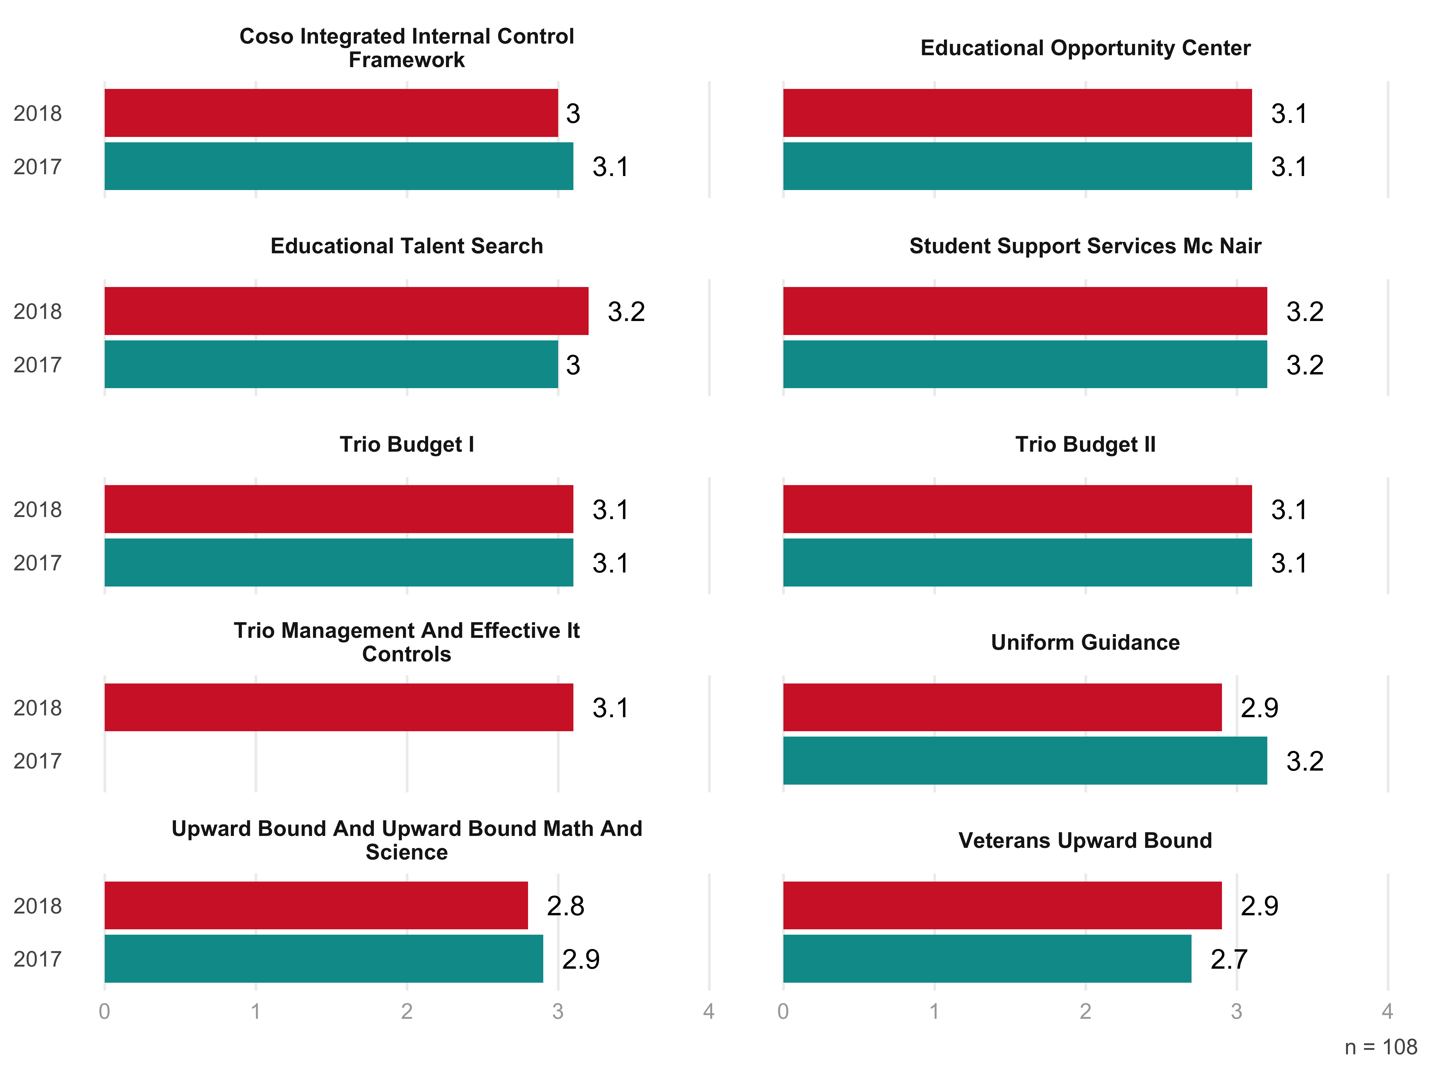

For hybrid courses, there are larger differences in the ratings between 2017 and 2018. The two courses with the biggest gaps are Veterans Upward Bound (3.0 in 2018, 2.5 in 2017) and Student Support Services McNair (2.7 in 2018, 3.2 in 2017).

Figure 8: Hybrid Course Ratings

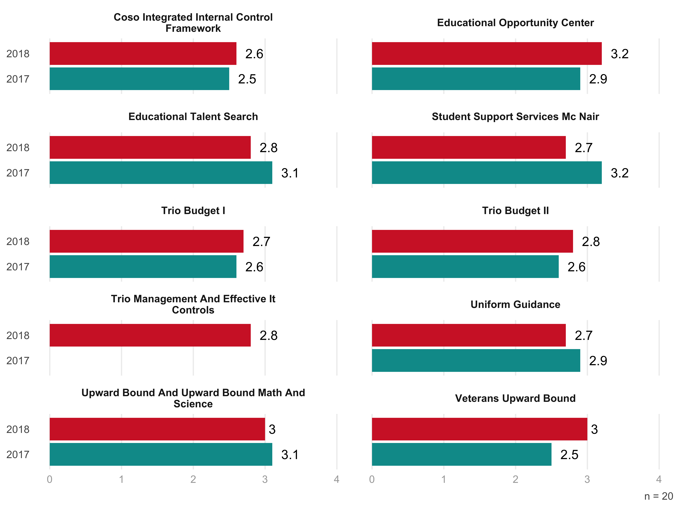

In person courses also showed some differences between this year and last year. The Education Opportunity Center course jumped from an average rating of 2.6 in 2017 to 3.1 in 2018. In contrast, the Upward Bound and Upward Bound Math and Science course dropped from 3.4 to 3.0.

Figure 9: In Person Course Ratings

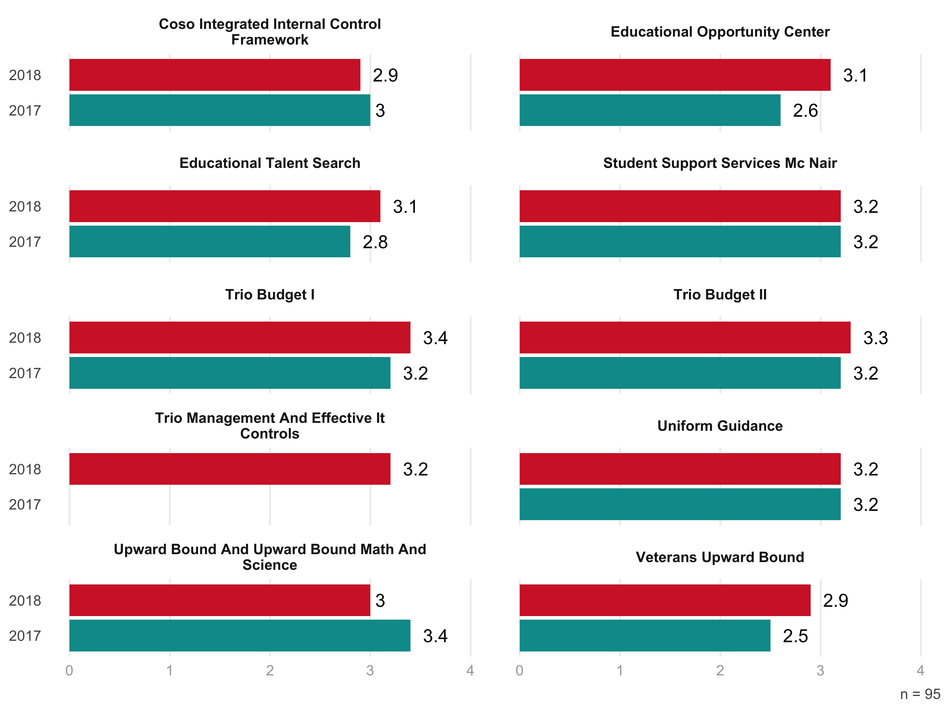

In follow-up comments describing their experience with the trainings, participants were overwhelmingly positive. One representative comment, for instance, was as follows: “This training is needed to all those new to TRIO upon hire! This is really the “meat and gravy” of the projects.” Another participant wrote, “I only expected to learn about budgeting, but I learned much more than that.” And a third added that the sessions had “great speakers and information.”

In terms of constructive criticism, there were two main suggestions. One person wrote, “I would prefer a LIVE trainer rather than watching videos of training.” Another said she “would [have] loved to be able to some working examples.”

# Training Satisfaction

Looking at participants’ satisfaction with variuos aspects of the TRIO training sessions, we can see that they were most pleased with opportunities to ask questions and receive feedback. The lowest satisfaction ratings came in relation to quizzes (3.1 out of 4).

Figure 10: Overall Satisfaction with Aspects of TRIO Trainings

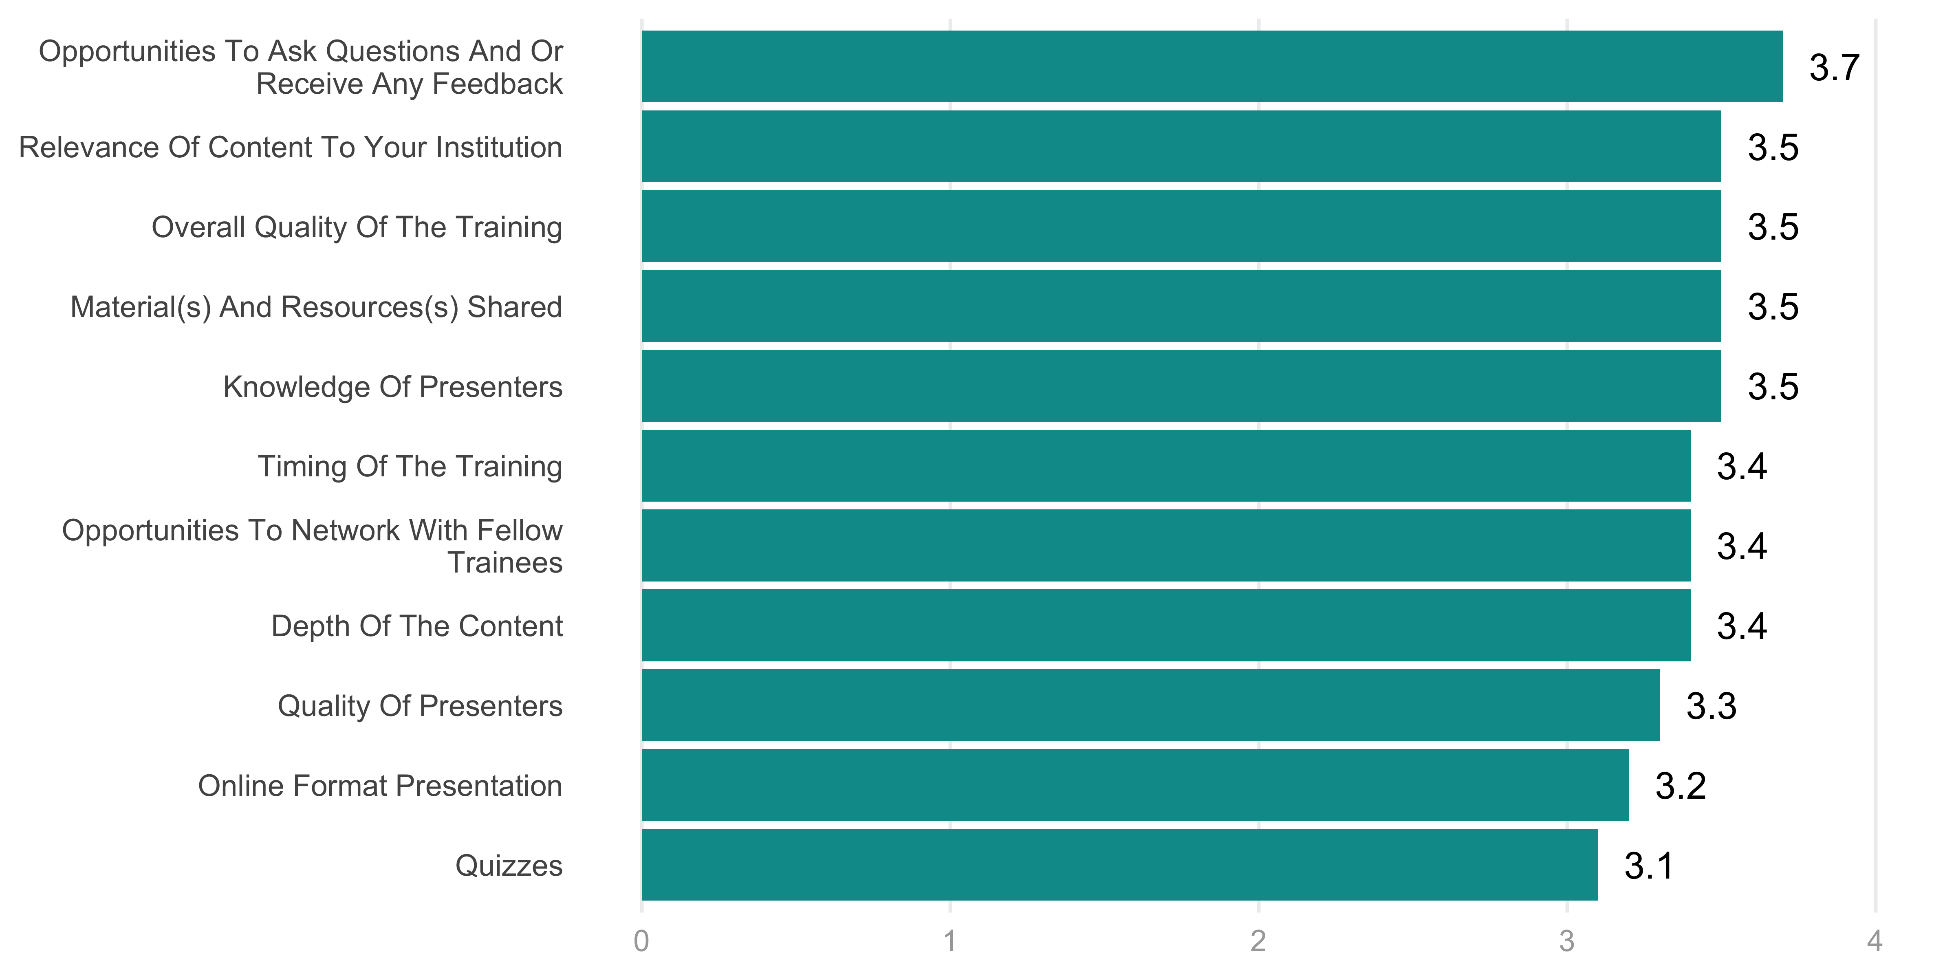

n = 108

Comparing across type of trainings, it is clear that the most highly-rated courses were those given in the in-person format. These courses had an average rating of 3.6. Hybrid courses and online courses both had average ratings of 3.2.

Breaking this down by individual aspects of satisfaction, you can see below the how participants rated each type of training in each area.

Figure 11: Overall Satisfaction with Aspects of TRIO Trainings by Training Type

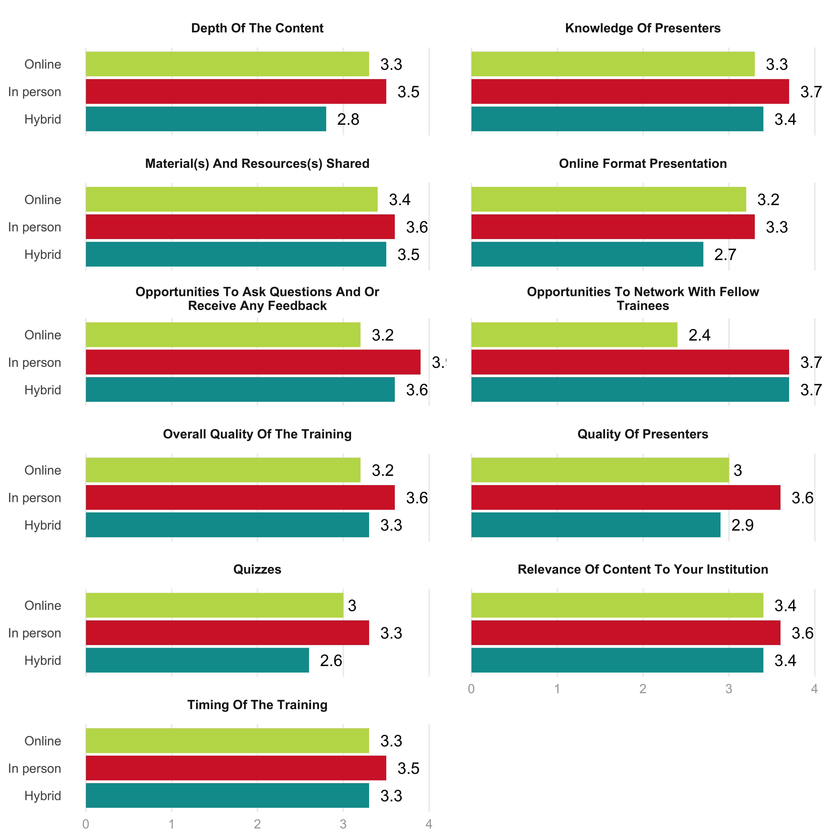

n = 108

Comparing satisfaction levels between years, we can see that the ratings are higher for 2018 than they were in 2017. Particularly notable is the question around opportunities to ask questions and receive feedback. This item had an average rating of 2.6 in 2017, but jumped to 3.2 in 2018. This was likely the result of the Q&A sessions that organizers added this year.

Figure 12: Online Course Satisfaction

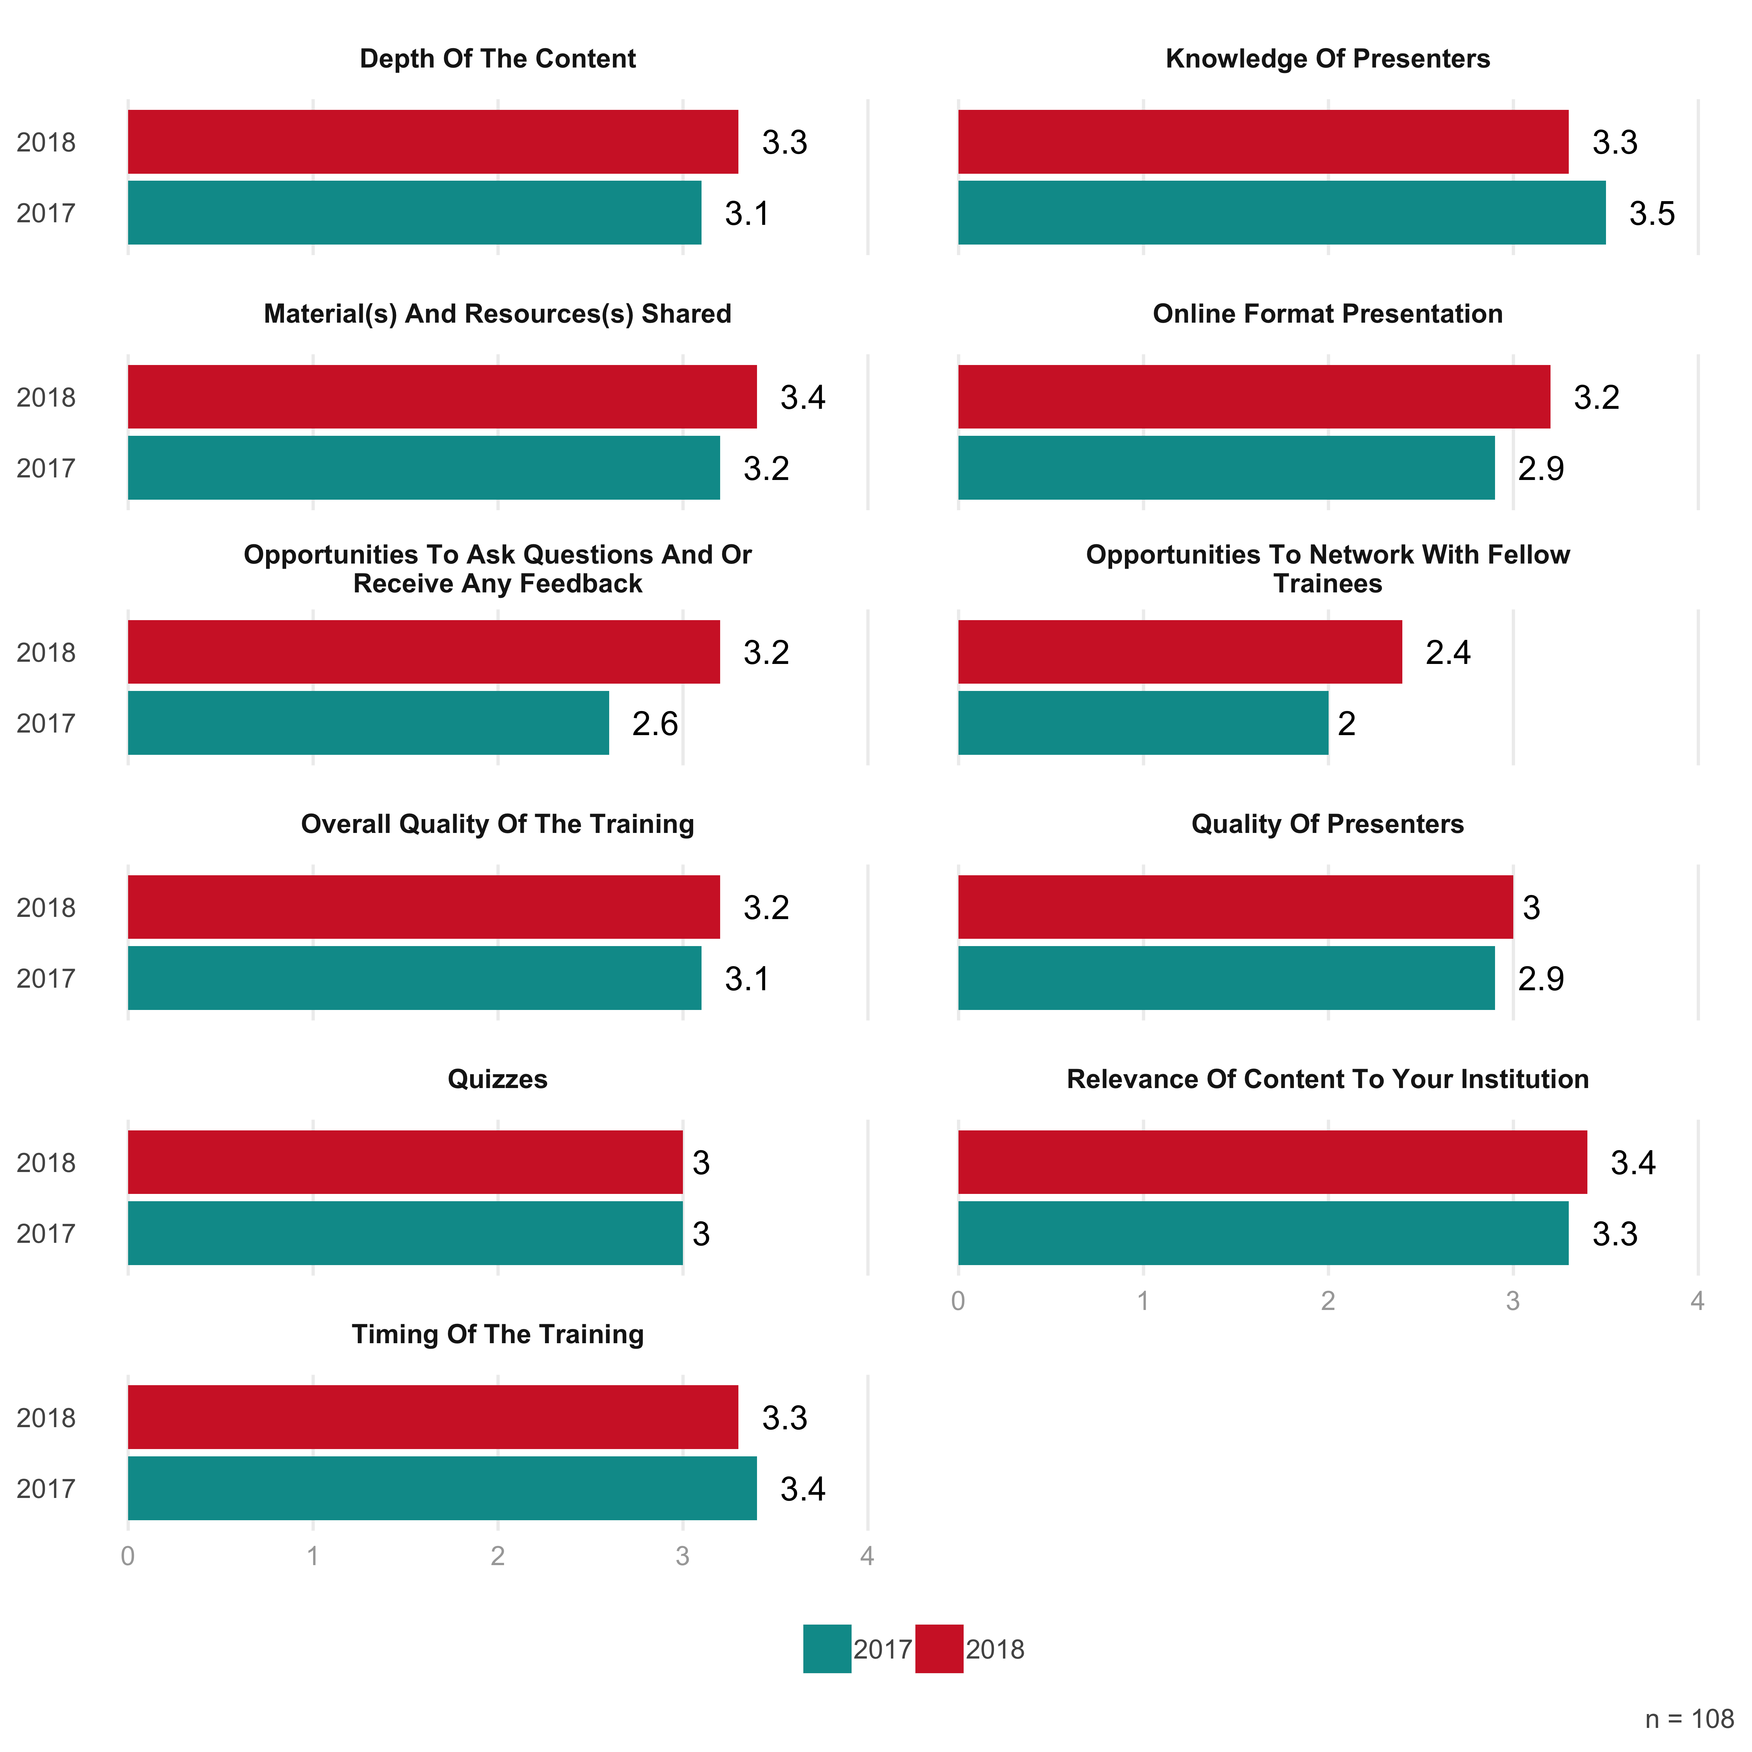

For hybrid sessions, the largest gap was on opportunities to network with fellow trainees. The 3.7 rating in 2018 was a full point above the 2.7 rating in 2017. The one area of concern is with regard to depth of content, which dropped from 3.4 in 2017 to 2.8 in 2018.

Figure 13: Hybrid Course Satisfaction

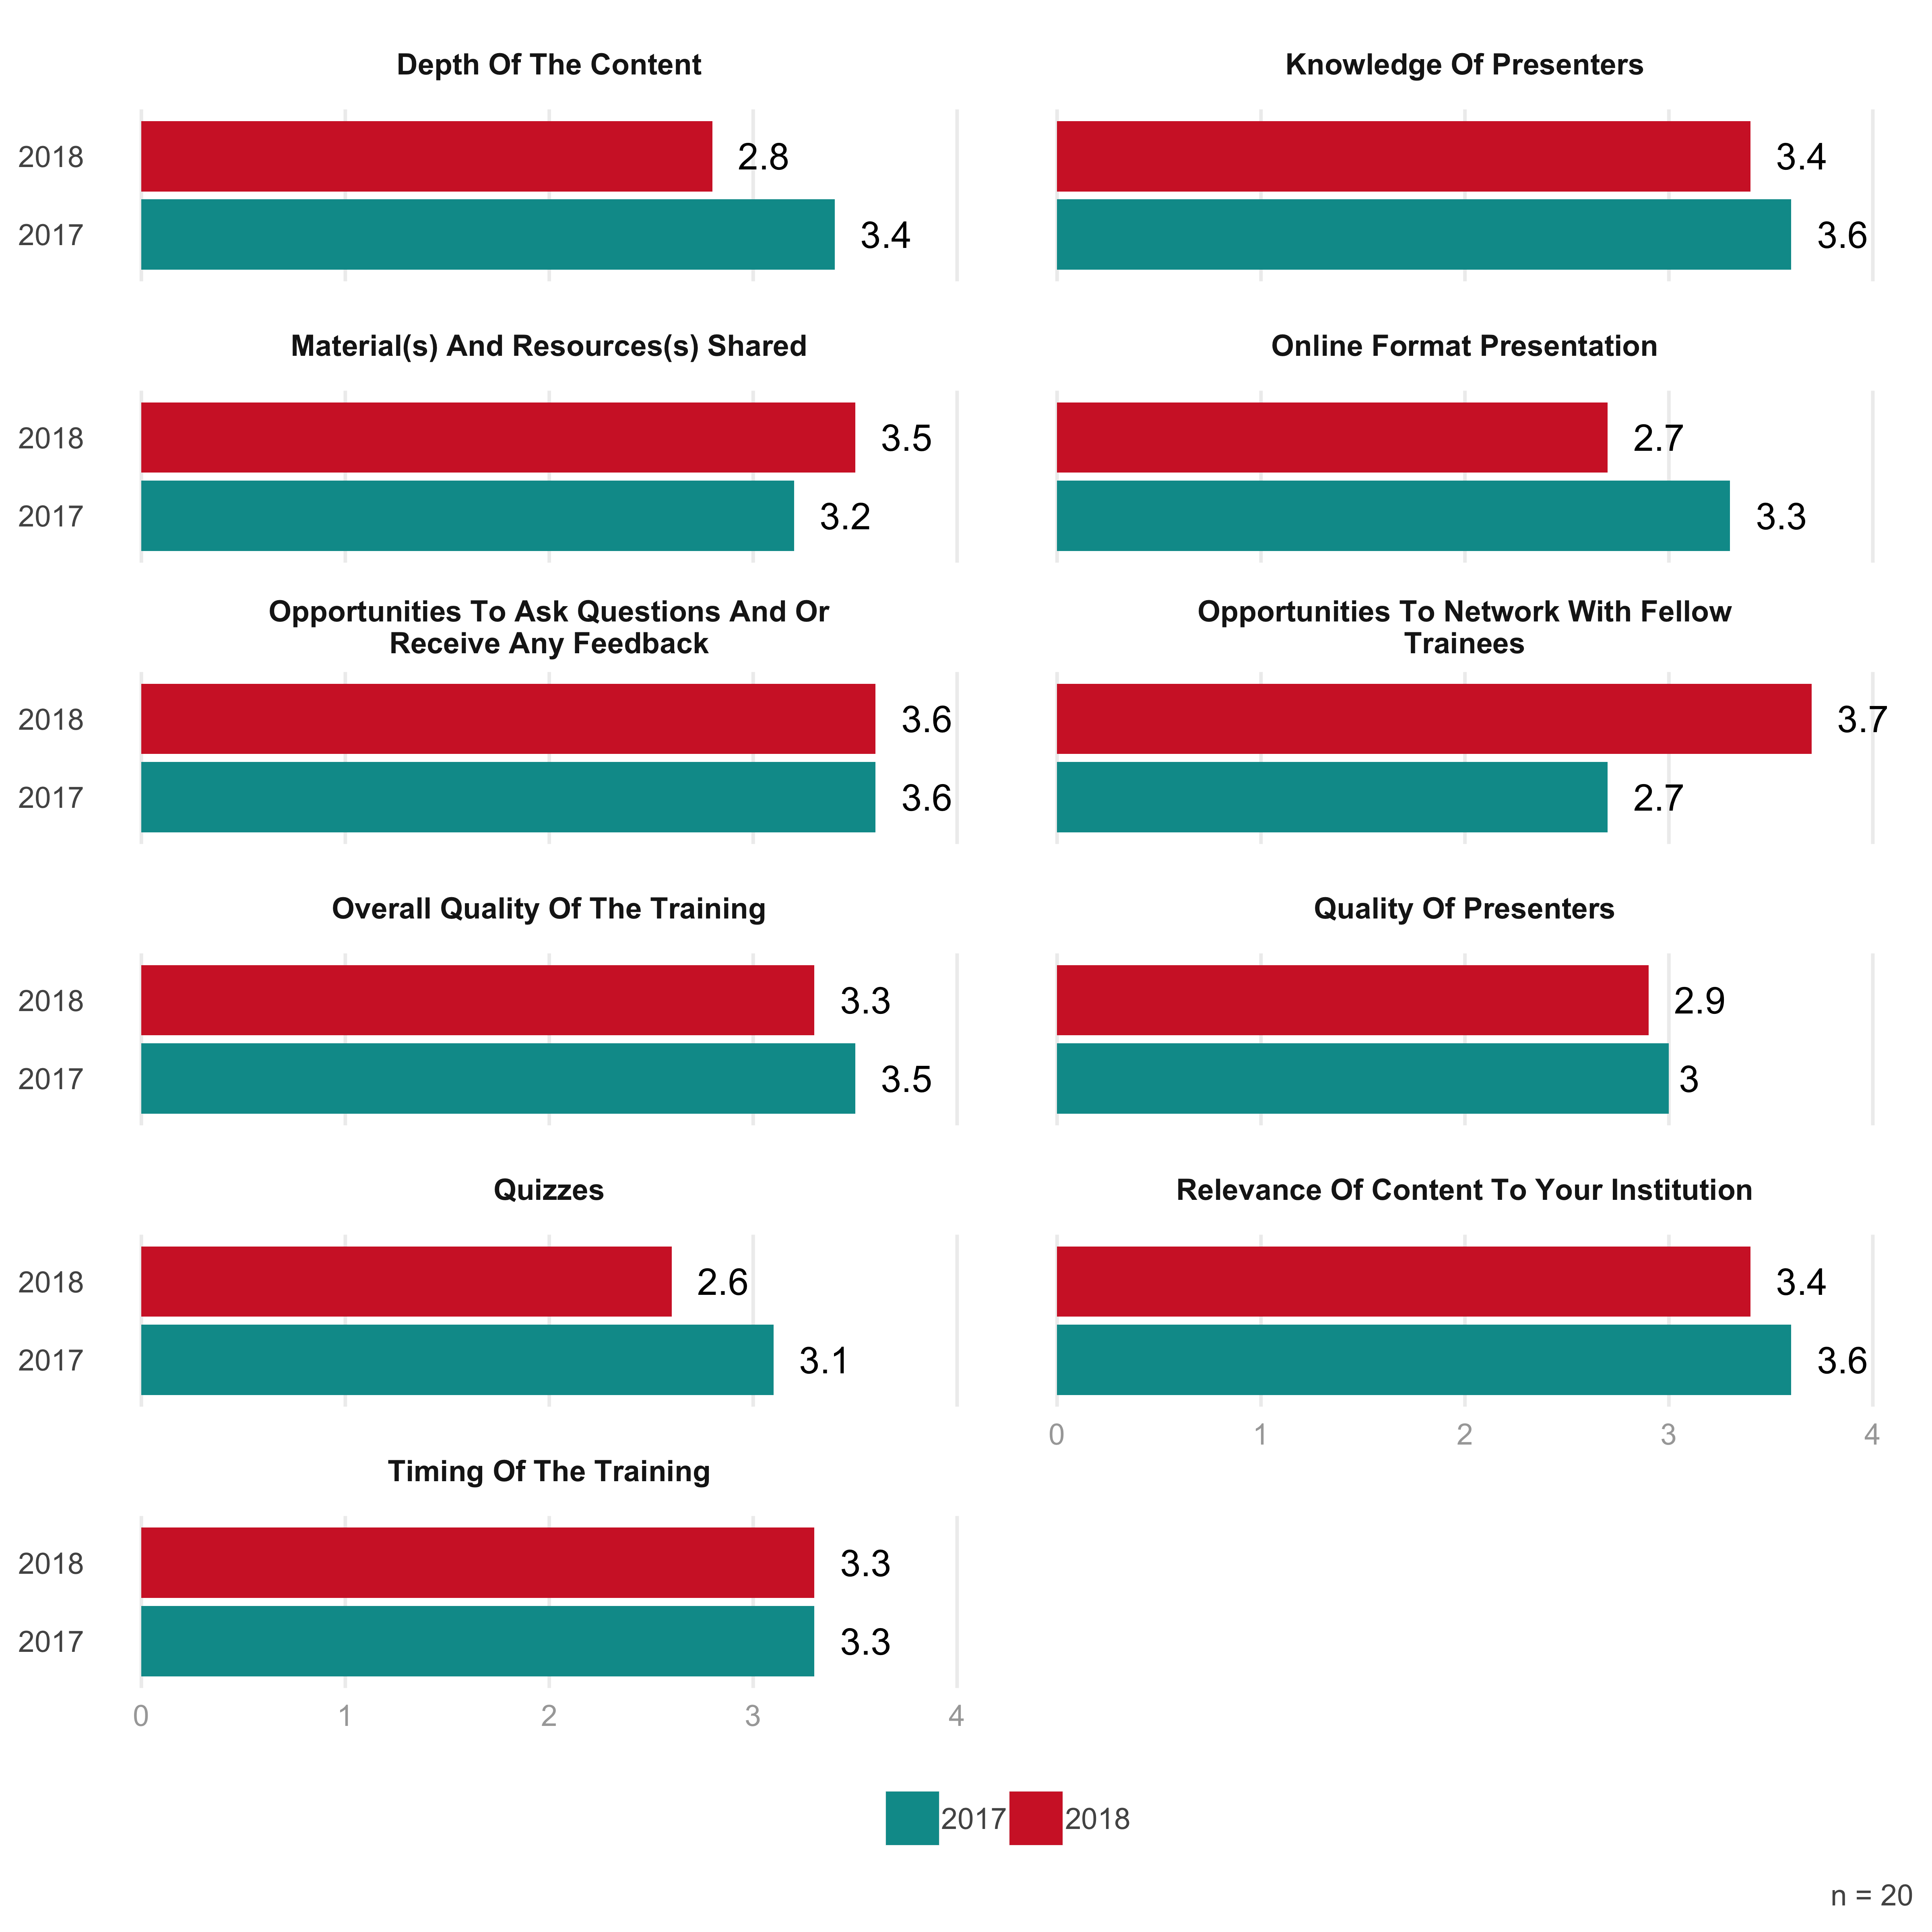

n = 108

In person trainings saw growth in satisfaction levels in every area.

Figure 14: In Person Course Satisfaction

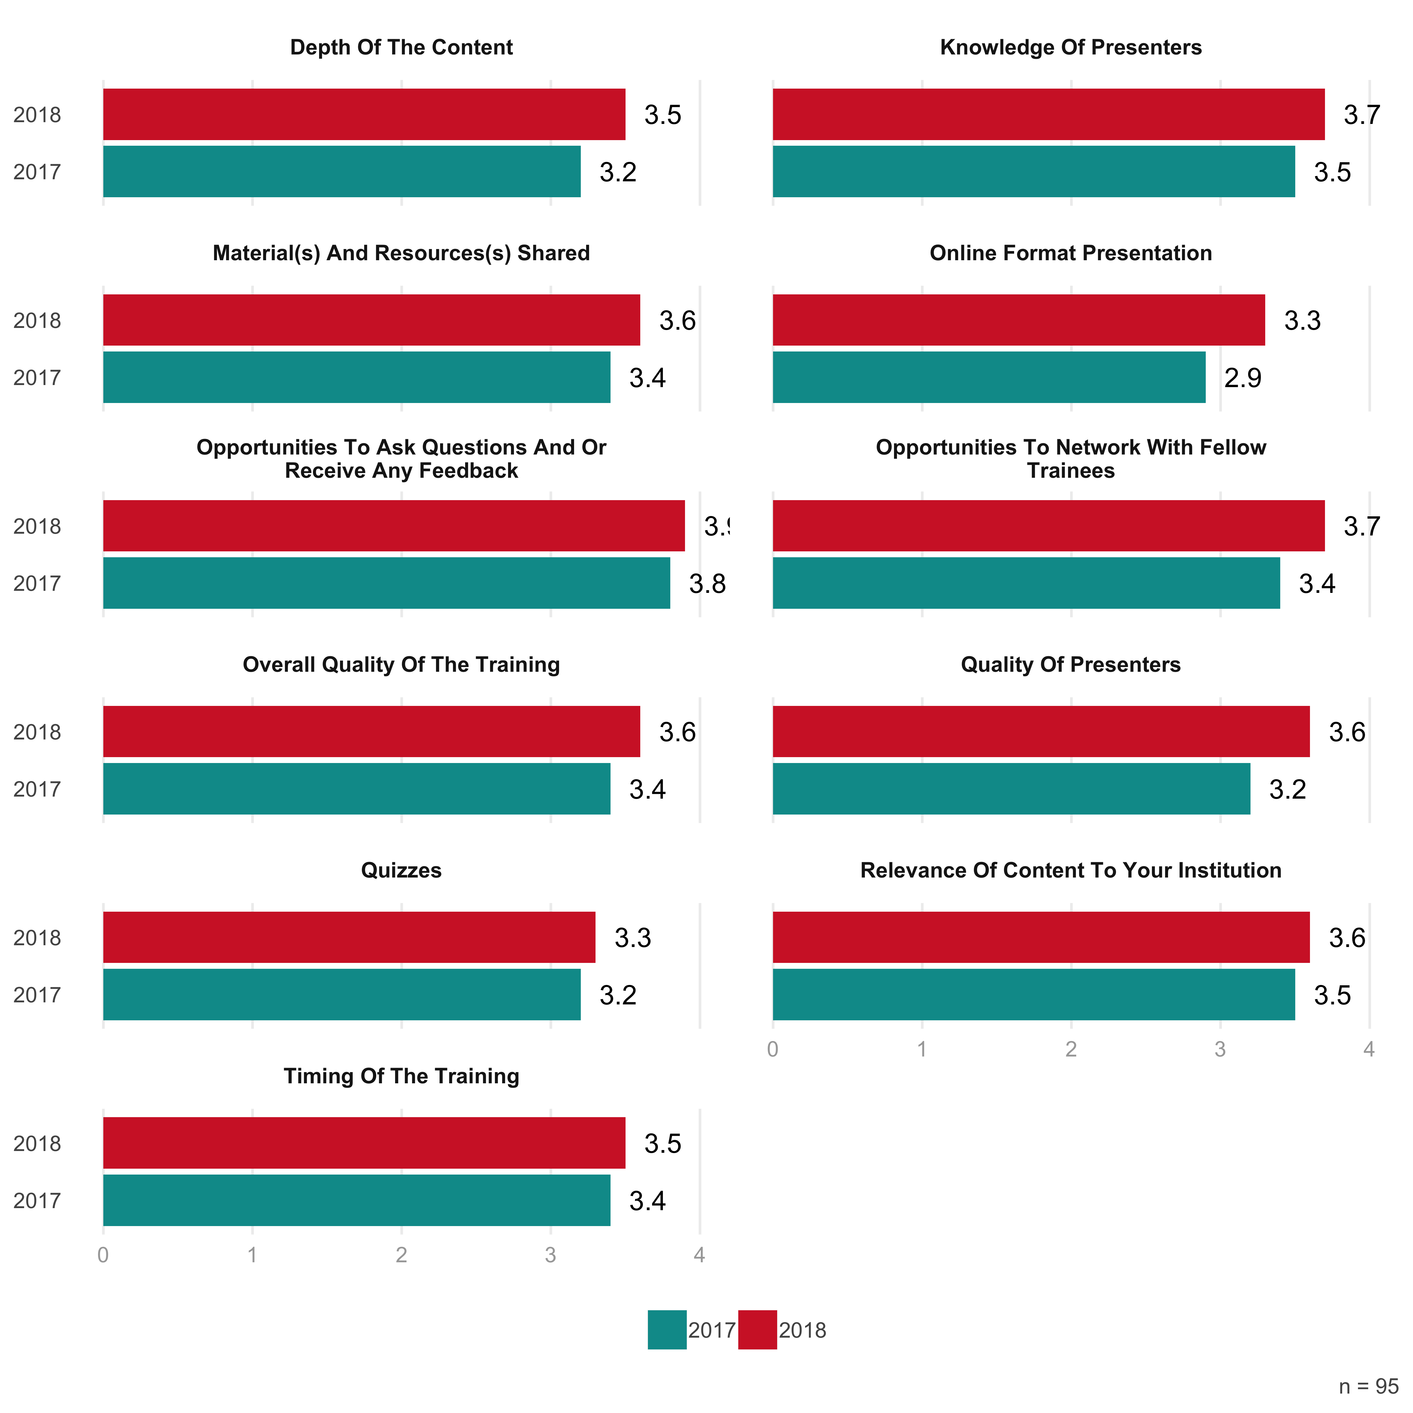

Among those who listed lower ratings for their satisfaction, their feedback illuminated a few areas of potential improvement, nearly all of which focused on the online sessions. Several participants mentioned that the online sessions were not as dynamic as they hoped they might be. One, for instance, wrote: “I found the videos to be boring and slightly disappointing although the organizers were delightful and generous hosts,” a comment echoed (on both fronts) by several others. Participants also noted that the online quizzes were not particularly challenging, and did not measure whether they had truly learned the materials (one mentioned taking a quiz before watching a video and passing it). A third area of feedback was around networking. That the “online format doesn’t really allow for effective networking” was a common refrain.

# Knowledge Growth

Among the most important goals of the trainings is to see an increase in the knowledge of participants. As Figure 15 below demonstrates, participants demonstrated significant knowledge growth after all trainings in the past two years.

Figure 15: Knowledge Growth (Pre and Post)

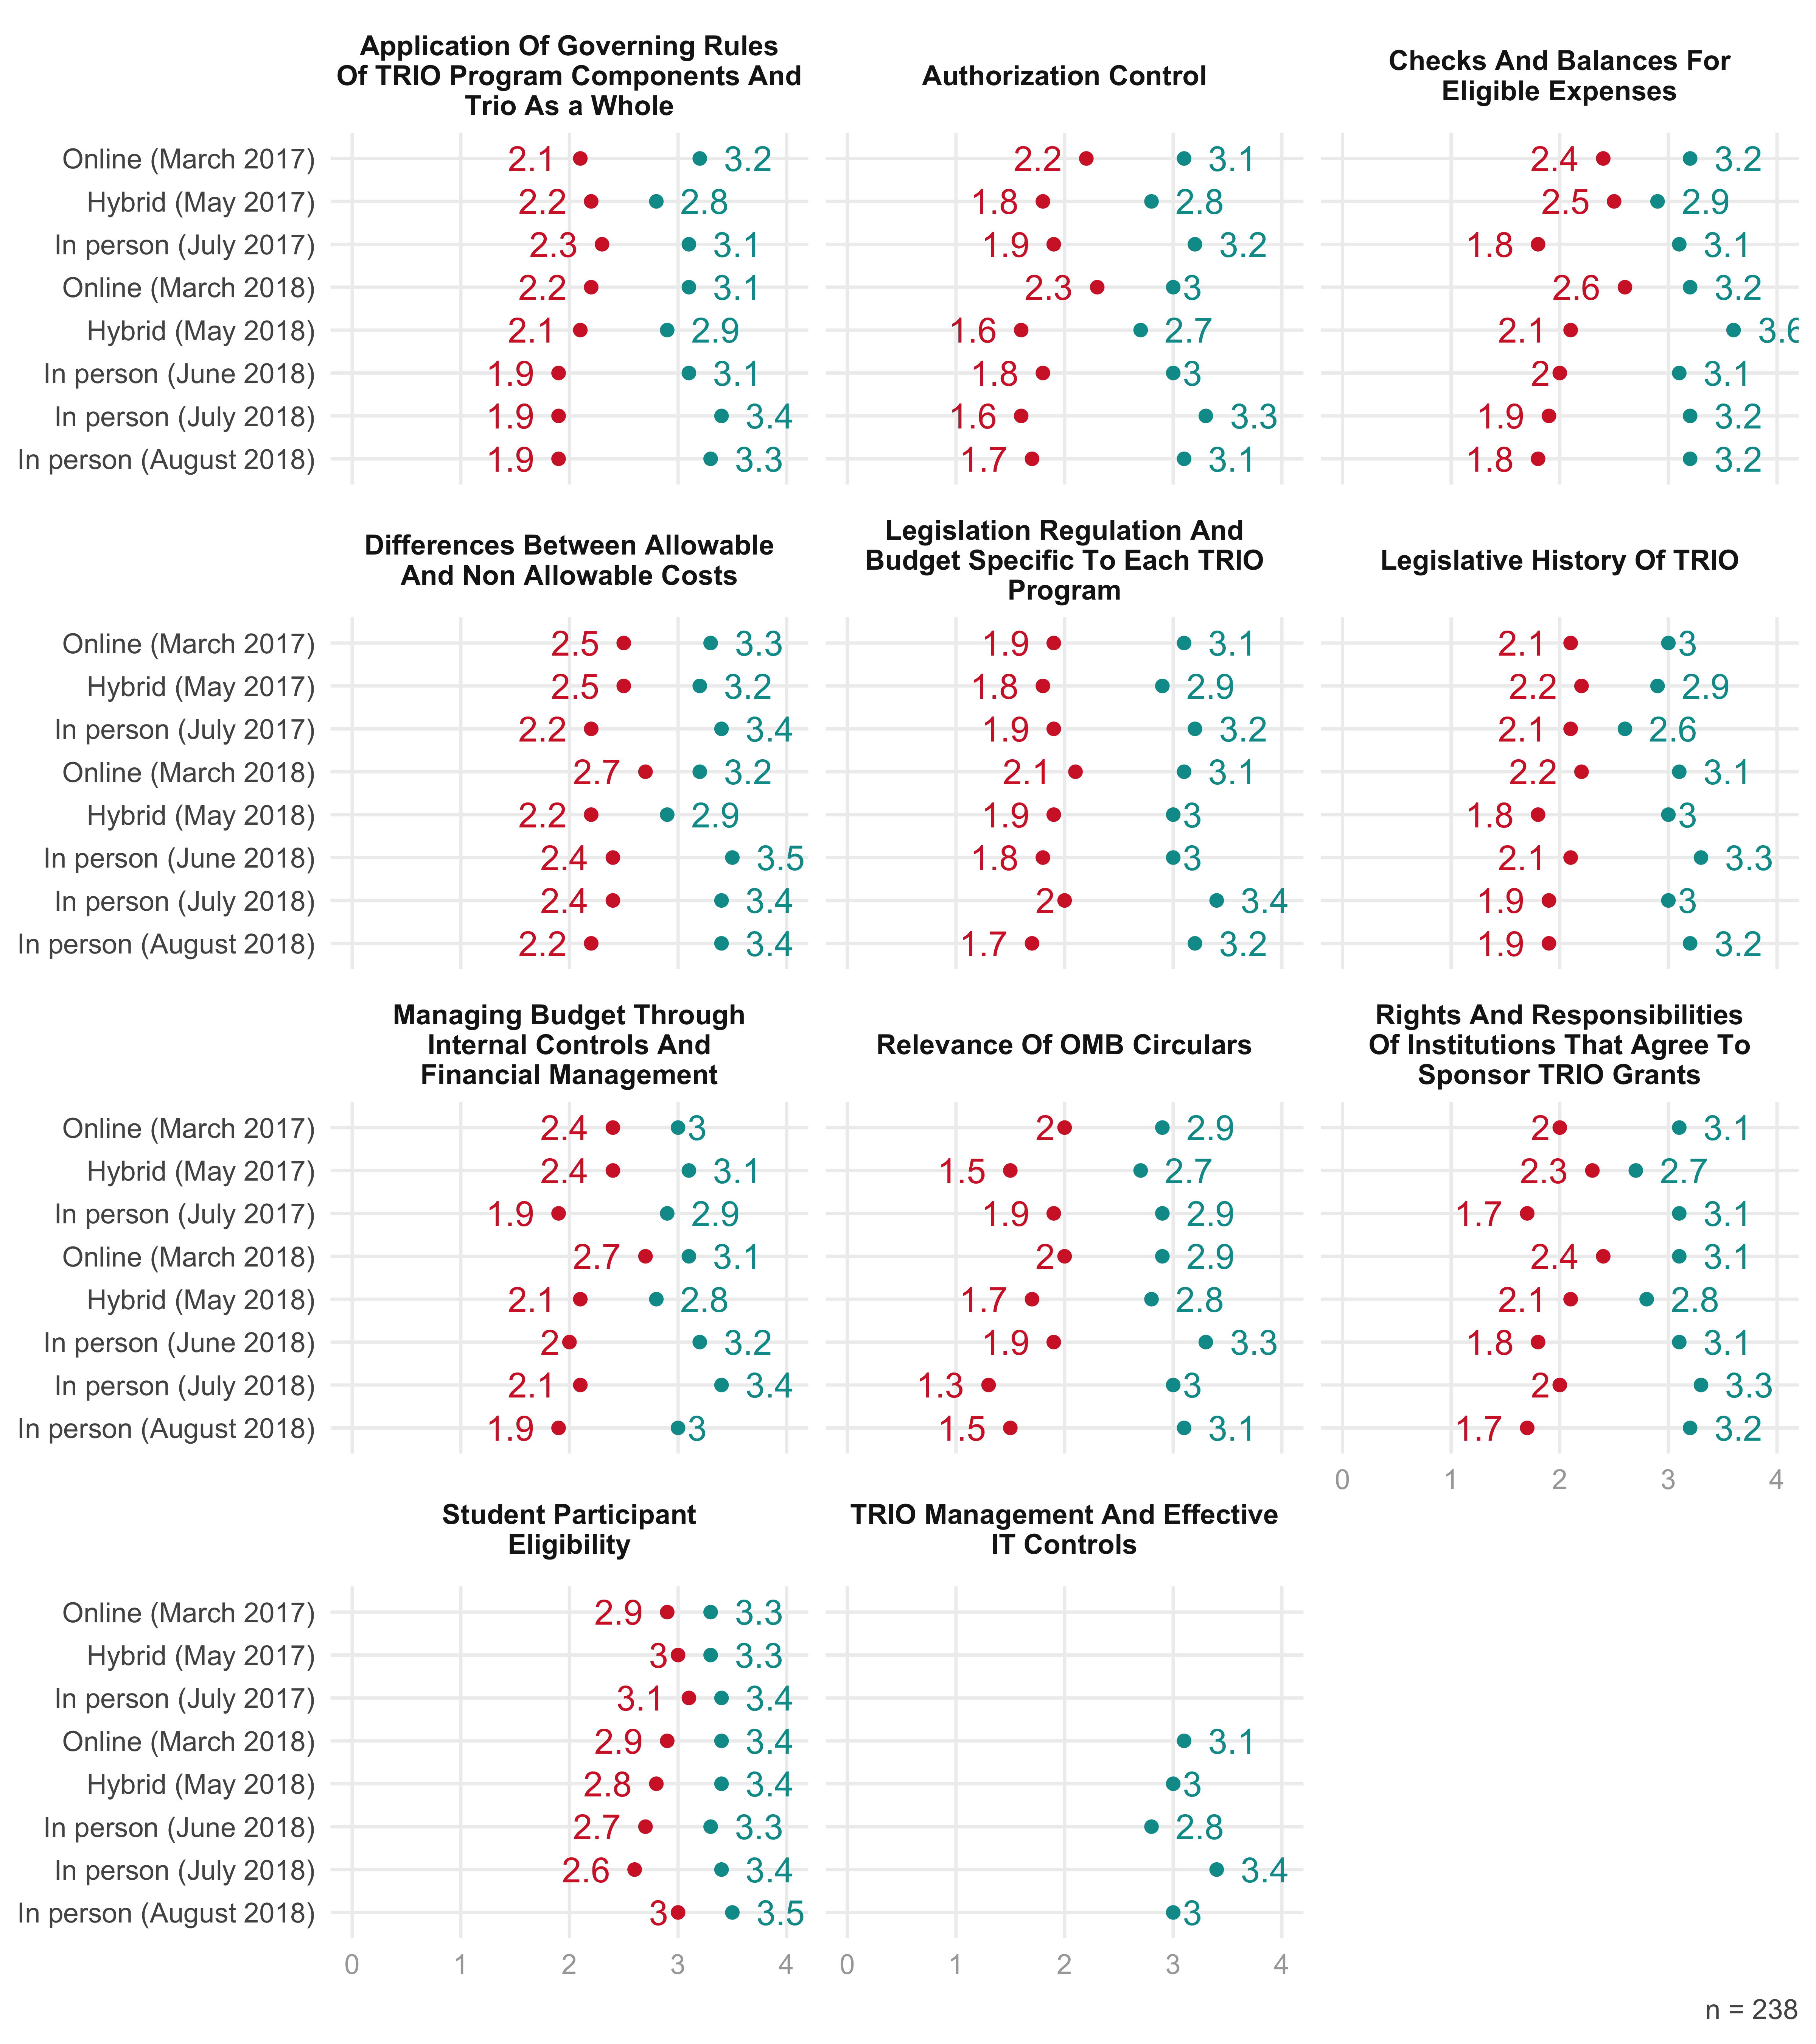

# Other Feedback

Participants also responded to a question about whether they would want a follow-up session. The largest response was maybe, followed by yes. Only 26 respondents (22 percent) said no.

Figure 16: Would Participants Want a Follow-Up Session?

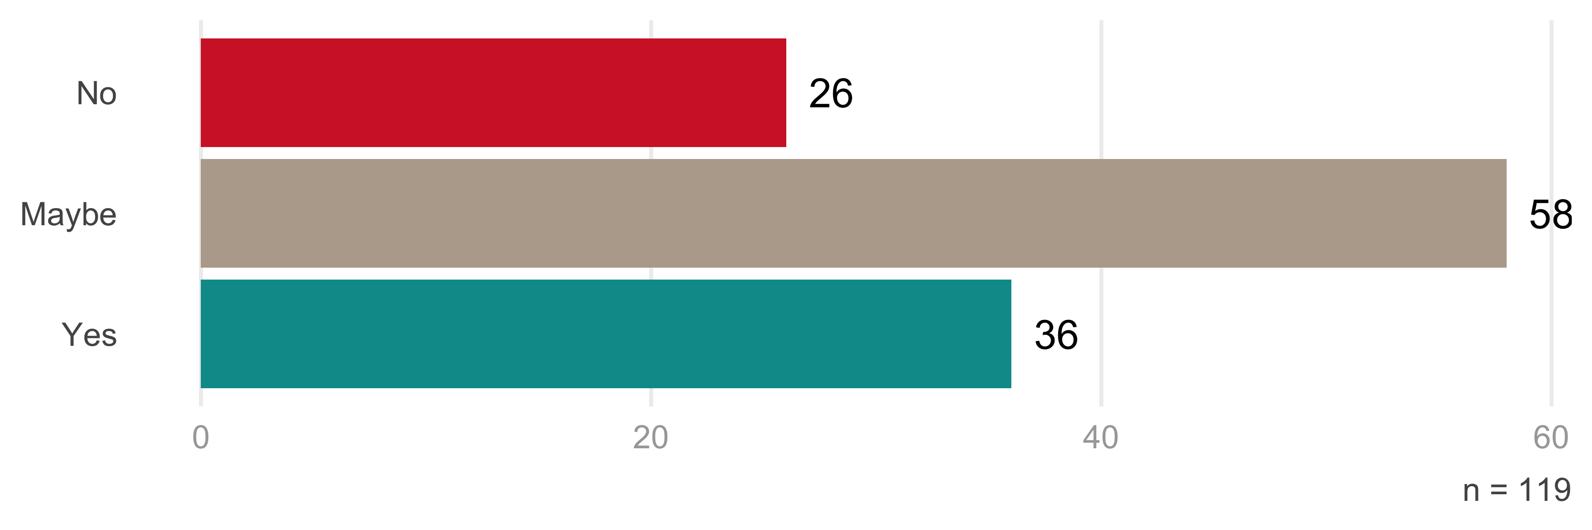

An overwhelming number of participants said they would recommend the training to a colleague. This, perhaps more than anything else, indicates their satisfaction with the trainings.

Figure 17: Would Participants Recommend the Training to a Colleague?

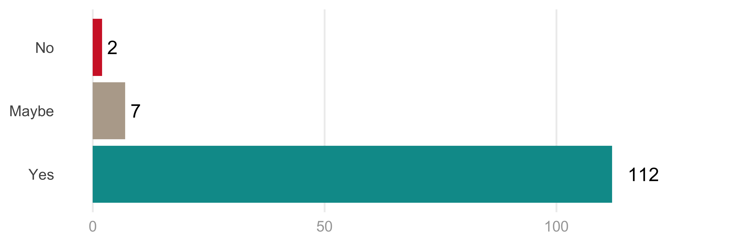

n = 121

Participants were also asked what other topics or ways of presenting content could be added for future sessions. Several identified the idea of conducting break-out groups by role, enabling those in similar positions across institutions to compare experiences and learn from each other. One participant wrote that she’d like to see a “leadership-focused training” covering “how to be a leader in the program for staff, students, colleges/organizations, and for the community.” Another respondent suggested a training specifically for new directors.

Other suggestions focused on participants wanting to learn from other TRIO participants. A particularly perceptive comment said, “I’d love to see a master list/document that could be contributed to and shared by all of us that has ideas for ways to do effective programming on the cheap, and in general, what other programs are doing to serve their students.”

# Conclusion and Recommendations

As Cuyahoga Community College wraps up its two-year grant from the United States Department of Education, it has offered trainings to over 300 participants from across the country. Overall, those who took part in the trainings appear to have enjoyed them and experienced significant learning. As was the case last year, in-person trainings were rated most highly by participants.

Based on feedback from last year’s report, Cuyahoga Community College made several changes to the TRIO trainings. One of these was to make the online courses more interactive. They did so by adding a webinar question and answer session to online sessions. This appears to have led to some improvement in satisfaction with online courses this year. However, there is still room for further interactivity to increase satisfaction with and learning as part of online courses. Several participants mentioned the online presentations being less than dynamic. And several more online participants wished that there had been opportunities for networking as part of their training. Using an online message board or something similar might be a strategy to enable participants who are not physically together to engage more directly with each other. Indeed, the desire for more peer interactions was one of the main themes in feedback from participants. The suggestion to provide opportunities for those in similar roles across institutions to interact with each other (e.g. directors working with other directors) is one to be considered as well.

# Works Cited

Chen, H. T. (1990). *Theory-driven evaluations*. Newbury Park, CA: SAGE Publications.

Chen, H. T. (2005). *Practical program evaluation*. Thousand Oaks, CA: SAGE Publications.

McLaughlin, J. A., & Jordan, G. B. (1999). Logic models: A tool for telling your program’s performance story. *Evaluation and Program Planning, 22*(1), 65-72.

1. https://www2.ed.gov/about/offices/list/ope/trio/index.html
2. https://forms.tri-c.edu/PathwaysTRiOTrainingForm